Code Design – PI Tracking

Design Points

1. Overview:

Server side processing will be done by a servlet that will query the database, and serve as a controller, view would be an html. View and controller would communicate by ajax calls, view would send query details by ajax to the controller query results would be formed as CSV and communicate back to the view.

1. Using the generated text files:

For this design I do not seem to find any point in using the generated text files, the stat5.txt hourly scripts have only counts they don’t have study or task names data so there are relevant to only a few of my queries. The text file that is used by details.jsp contains study names and task names but doesn't seem to query session status, so it also only relevant to some of my queries.

1. Caching:

Oracle 11g has its own catching mechanism especially the relatively new 'result caching', having looked at this catching mechanism it seems not to help us much the query result is cached but it is invalidated once the underlying table is modified and seems there isn’t any way to change this behavior. We can save small frequently used queries in memory or save to disk.

UML Chart

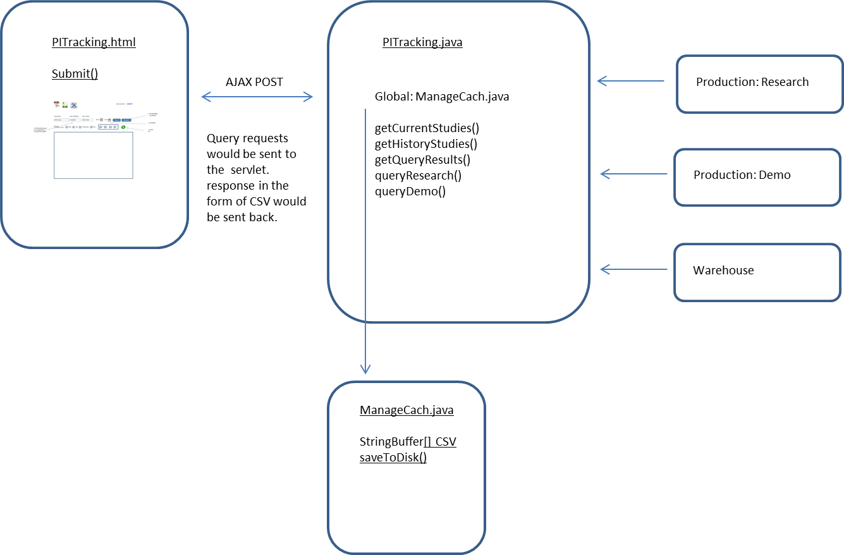

**PITracking Function Summery**

**Function: getCurrentStudies()**

Description: go over the Randomconfig.xml and read current study names.

Input: gets physical path to file from Implicit.java

Return: array of study names

**Function: getHistoryStudies()**

Description: go over the HistoryRandomconfig.xml and read current study names.

Input: gets physical path to file from Implicit.java

Return: array of study names

**Function: getQueryResults()**

Description: responsible to get the relevant array of study names filtered it according to study name that was entered and for each study query the DB according to task name and other parameters.

Input: Study name, Task name, Date range, data group, studies status (current/history).

Return: results in the form CSV.

**Function: QueryResearch()**

Description: query the research data base uses implicit naming resources. Query Session_V and SessionTask_V.

Input: Date range, array of study names.

Return: result set.

**Function: QueryDemo()**

Description: query the demo data base uses implicit naming resources. Query Session_V and SessionTask_V.

Input: Date range, array of study names, Task name

Return: result set.

ManageCach.java

StringBuffer[] CSV : Array of CSV of relevant Queries.

Function SynceToDisk()

Description: Save CSV to disk and release it from memory.

Input:

Return: